WEEK 2

READABILITY

#include <cs50.h>

#include <stdio.h>

#include <ctype.h>

#include <string.h>

#include <math.h>

int main(void)

{

int count_letter = 0;

int count_word = 1;

int count_sentence = 0;

string text = get_string("Text: ");

int text_length = strlen(text);

for (int i = 0; i < text_length; i++)

{

if(isalpha(text[i]))

{

count_letter++;

}

}

//printf("%i\n", count_letter);

for (int i = 0; i < text_length; i++)

{

if (isspace(text[i]))

{

count_word++;

}

}

for (int i = 0; i < text_length; i++)

{

if (text[i] == '.' || text[i] == '?' || text[i] == '!')

{

count_sentence++;

}

}

float calculation = (0.0588 * count_letter / count_word * 100) - (0.296 * count_sentence / count_word * 100) - 15.8; // to calculate Index

int index = round(calculation);

if (index < 1) //

{

printf("Before Grade 1\n");

}

else if (index > 16)

{

printf("Grade 16+\n");

}

else

{

printf("Grade %i\n", index);

}

}

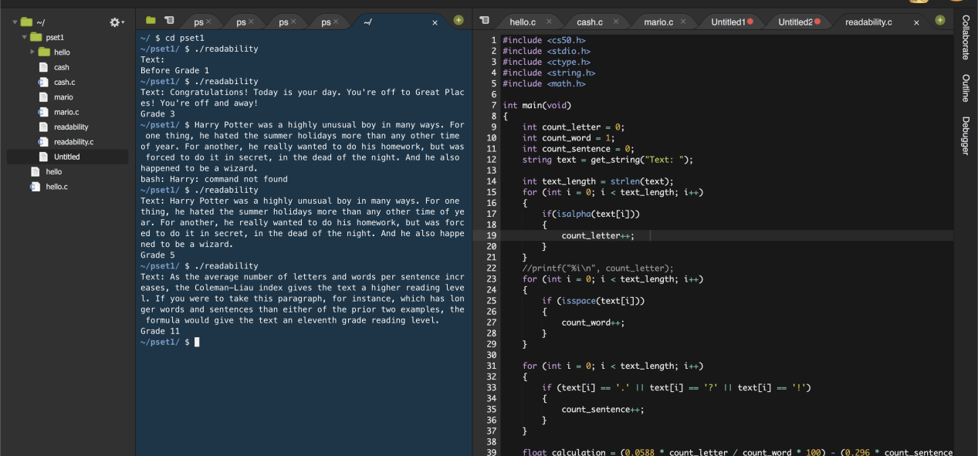

CAESER)

#include <cs50.h>

#include <stdio.h>

#include <string.h>

#include <ctype.h>

#include <stdlib.h>

int main(int argc, string argv[])

{

if (argc != 2)

{

printf("Usage: ./caesar key\n");

return 1;

}

int arg_length = strlen(argv[1]);

for (int i = 0; i < arg_length; i++)

{

if (!isdigit(argv[1][i]))

{

printf("Usage: ./caesar key");

return 1;

}

}

int key = atoi(argv[1]);

string plaintext = get_string("plaintext: ");

printf("ciphertext: ");

int plaintext_length = strlen(plaintext);

for (int i = 0; i < plaintext_length; i++)

{

if (isupper(plaintext[i]))

{

printf("%c", (((plaintext[i] - 65) + key) % 26) + 65);

}

else if (islower(plaintext[i]))

{

printf("%c", (((plaintext[i] - 97) + key) % 26) + 97);

}

else

{

printf("%c", plaintext[i]);

}

}

printf("\n");

}

